ACCOUNTING OF SHARE CAPITAL
The Section 3 (1) (i) of the Company Act of 1956 defines an organisation as a company that is formed and registered under the Act or any existing company that is formed and registered under any earlier company laws. In general, a company is an artificial person, created by law that has a separate legal entity, perpetual succession, common seal and has limited liability. It is a voluntary association of person who together contributes in the capital of the company to do business. Generally, the capital of a company is divided into small parts known as shares, the ownership of which is transferable subject to certain terms and conditions. There are two types of company, public company and private company.
Characteristics of Company
1. Association of Person: A company is formed voluntarily by a group of persons to perform a common business. Minimum number of person should be two for formation of a private company and seven for a public company.
2. Artificial Person: Company is an artificial and juristic person that is created by law.
3. Separate Legal Entity: A company has a separate legal entity from its members (shareholders) and Directors. It can open a bank account, sign a contract and can own a property in its own name.
4. Limited Liability: The liability of the members of a company is limited up to the nominal value or the face value of the shares. Unlike a partnership firm, on insolvency of a company, the members and the shareholders are not liable to pay the amount due to the creditors of the company. In fact, the members and the shareholders are only liable to pay the unpaid amount of the shares held by them. For example, if the value of share is Rs 10 and Rs 6 is paid up, then the member is liable to pay only Rs 4.
5. Perpetual Existence: The existence of company is not affected by the death, retirement, and insolvency of its members. That is, the life of a company remains unaffected by the life and the tenure of its members in the company. The life of a company is infinite until it is properly wound up as per the Company Act.
6. Common Seal: The Company is an artificial person and has no physical existence; hence it cannot put its signature. Thus, the Common Seal acts as an official signature of a company that validates the official documents.
7. Transferability of Shares: The shares of public limited company is easily and freely transferable without any consent from other members. But the share of ownership of a private limited company is not transferable without the consent of the other members.

A public company is defined as a company that offers a part of its ownership in the form of shares, debentures, bonds, securities to the general public through stock market. There must be atleast seven members to form a public company. As per the section 3 (1) (iv) of Companies Act 1956, public company means a company which:
a) is not a private company,
b) has a minimum paid up capital of Rs 5,00,000 or such higher paid up capital, as may be prescribed,
c) is a private company, being a subsidiary of a company which is not a private company.
A public company should not be mistakenly understood as a publicly-owned company, as the latter is exclusively owned and controlled by the government. A public company issues its share to general public without any restriction on maximum number of persons. A public company can be segmented into two types:
1. Listed Company- A Company whose shares are listed and traded in the stock exchange like, Tata Motors, Reliance, etc.
2. Unlisted Company- A Company whose shares are not listed in the stock exchange and thereby these shares cannot be traded in the stock exchange.

Question 2:
What is private limited company?

ANSWER:
Private limited company is a company that is limited by shares or by guarantee by its members. A private limited company is defined as a company that has a minimum paid up share capital of Rs 1,00,000. As defined by the Section 3 (1) (iii) of Companies Act 1956, private limited company is defined by the following characteristics:
a) It restricts the right to transfer its shares.
b) There must be atleast two and a maximum of 50 members (excluding current and former employees) to form a private company.
c) It cannot invite application from the general public to subscribe its shares, or debentures.
d) It cannot invite or accept deposits from persons other than its members, Directors and their relatives.
Unlike public company, a private company cannot issue its shares or debentures to general public at large as shares of these companies are not traded in the stock exchange, for example, Coca-Cola India Private limited, etc.
What is a ‘Preference Share’? Describe the different types of preference shares.

ANSWER:

COMPANY’S BALANCE SHEET- As per REVISED SCHEDULE VI
Name of the Company…
BALANCE SHEET
as on…
Particulars | Note No. | Figures as at the end of Current Year | Figures as at the end of the Previous Year
I. EQUITY AND LIABILITIES
(1) Shareholders’ Funds
(a) Share Capital
(b) Reserves and Surplus
(c) Money received against Share Warrants
(2) Share Application Money Pending Allotment
(3) Non-Current Liabilities
(a) Long-Term Borrowings
(b) Deferred Tax Liabilities (Net)
(c) Other Long-Term Liabilities
(d) Long-Term Provisions
(4) Current Liabilities
(a) Short-Term Borrowings
(b) Trade Payables
(c) Other Current Liabilities
(d) Short-Term Provision
TOTAL
II. ASSETS
(1) Non-Current Assets
(a) Fixed Assets
(i) Tangible Assets
(ii) Intangible Assets
(iii) Capital Work-in-Progress
(iv) Intangible assets under development
(b) Non-Current Investments
(c) Deferred tax assets (net)
(d) Long-Term Loans and Advances
(e) Other Non-Current Assets
(2) Current Assets
(a) Current Investments
(b) Inventories
(c) Trade Receivables
(d) Cash and Cash Equivalents
(e) Short-Term Loans and Advances
(f) Other Current Assets
TOTAL

Preference Shares: Section 85 of the Company Act,1956 defines Preference Shares to be featured by the following rights:
a. Preference Shares entitle its holder the right to receive dividend at a fixed rate or fixed amount.
b. Preference Shares entitle its holder the preferential right to receive repayment of capital invested by them before their equity counterparts at the time of winding up of the company.
Types of Preference Shares
The different types of Preference Shares are diagrammatically explained below.
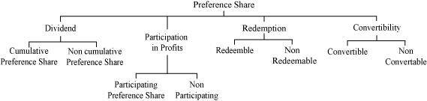
1. On the basis of Dividend:
a) Cumulative Preference Shares
When a preference shareholder has a right to recover any arrears of dividend, before any dividend is paid to the equity shareholders, then the type of Preference Shares held by the shareholder is known as Cumulative Preference Shares. All Preference Shares are cumulative unless otherwise expressly stated to be non cumulative.
b) Non Cumulative Preference Share
When a preference shareholder receives dividend only in case of profit and is not entitled any right to recover the arrears of dividend, then the type of Preference Shares held by the shareholder is known as Non Cumulative Preference Shares.
2. On the basis of Participation:
a) Participating Preference Share
When a preference shareholder enjoys the right to participate in the surplus profit (in addition to the fixed rate of dividend) that is left after the payment of dividend to the equity shareholders, the type of shares held by the shareholder is known as Participating Preference Share.
b) Non participating Preference Share
When a preference shareholder receives only a fixed rate of dividend every year and do not enjoy the additional participation in the surplus profit, then the type of shares held by the shareholder is known as Non Participating Preference Shares.
It must be noted that all Preference Shares are non-participating until and unless expressly stated.
3. On the basis of Redemption:
a) Redeemable preference share
When a preference shareholder is repaid by the company after a certain specified period in accordance with the term specified in the Section 80 of Company Act of 1956, then the type of the shares held by him/her is known as Redeemable Preference Shares.
b) Non Redeemable Preference share
These shares are not repaid by the company during its lifetime. As per the Section 80A of the Company Act of 1956, no company can issue Non Redeemable Preference Shares. It is merely a theoretical concept.
4. On the basis of Convertibility:
a) Convertible Preference Share
The shareholders holding Convertible Preference Shares have a right to convert his/her shares into equity shares.
b) Non Convertible Preference Share
Unlike Convertible Preference Shares, the shareholders holding Non Convertible Preference Shares do not enjoy the right to convert their shares into equity shares.
https://web.microsoftstream.com/video/4e62d32b-f8d8-4810-b16c-5b5281066dd5[link]

Understanding Prospectus
As per the Companies Act, 2013, a prospectus can include information such as advertisement, circular or notice among other legal documents inviting the public for the offering. Also, the prospectus should be issued only for the purchase of a company's securities.
In order for a document to be considered a prospectus, it should act as an invitation for the public to purchase of stocks/shares, debentures or other instruments. Also, the prospectus should be issued by the company or an institution on behalf of the company and made solely for the public.
In case a private company wishes to convert to a public company, it is required to either issue a prospectus or file a statement in lieu of prospectus of which the provisions are mentioned under Section 70 of the Companies Act, 2013.

12B Ltd.
Balance Sheet
Particulars | Note No. | Amount  (Rs)
I. Equity and Liabilities
1. Shareholders’ Funds
a. Share Capital | 1 | 10,00,000
2. Non-Current Liabilities |  | -
3. Current Liabilities |  | -
Total
II. Assets
1. Non-Current Assets |  | -
2. Current Assets |  | -
Total
NOTES TO ACCOUNTS
Note No. | Particulars |  | Amount  (Rs)
1 | Share Capital
 | Authorised Share Capital
 | 20,000 shares of Rs 100 each |  | 20,00,000
 | Issued Share Capital
 | 10,000 shares of Rs 100 each |  | 10,00,000
 | Subscribed, Called-up and Paid-up Share Capital
 | 10,000 shares of Rs 100 each
 |  |  | 10 ,00,000

Nominal value/ Face value of share/Par value of share—100
Application 30
Allotment 20
First call 30
Second and final call 20
Calls in Arrears
Calls in arrers a/c Dr.
To first call

Bank a/c Dr.
To calls in arrears
To interest
Calls in advance
Bank a/c Dr.
To calls in advance

Call s in advance a/c Dr.
Interest on calls in advance a/c Dr.
To first call
Over subscription and Undersubscription
When the total number of applications received for shares exceeds the number of shares offered by the company to the public, the situation of Over-subscription arises. A company can opt for any of the three alternatives to allot shares in case of Over-subscription of shares.

i) Excess applications are refused and money received on excess applications is returned to the applicants.
The company can refuse excess applications and the money received on these excess applications is returned to the applicants.

Share Application A/c 150000 |  | Dr.
 | To Share Capital A/c 100000
 | To Bank A/c 50000 [rejected]
(Excess application money returned)

Example: Shares issued 10,000 @ Rs 10 per share and money received for 12,000 shares. Amount is payable Rs 2 on application, Rs 5 on allotment, Rs 3 on first and final call.

Bank A/c |  | Dr. |  | 24,000
 | To Share Application A/c |  |  |  | 24,000
(Application money received for 12,000 shares)

Share Application A/c |  | Dr. |  | 24,000
 | To Share Capital A/c |  |  |  | 20,000
 | To Bank A/c |  |  |  | 4,000
(Application money transferred to Share Capital
Account and the excess money returned)

ii) Pro rata Basis
The company can allot shares on pro rata basis to all the share applicants. The excess amount received in the application is adjusted on the allotment.

Share Application A/c |  | Dr.
 | To Share Capital A/c
 | To Share Allotment A/c
(Adjustment of application money on allotment)

Example: Shares issued 10,000 @ Rs 10 per share and money received for 12,000 shares. Amount is payable Rs 2 on application, Rs 5 on allotment, Rs 3 on first and final call.

Bank A/c |  | Dr. |  | 24,000
 | To Share Application A/c |  |  |  | 24,000
(Application money received for 12,000 shares)

Share Application A/c |  | Dr. |  | 24,000
 | To Share Capital A/c |  |  |  | 20,000
 | To Share Allotment A/c |  |  |  | 4,000
(Application money transferred to Share Capital
Account and the balance amount is transferred to
Share Allotment Account)

Share Allotment A/c |  | Dr. |  | 50,000
 | To Share Capital A/c |  |  |  | 50,000
(Amount due on allotment of 10,000 shares @ Rs 5
per share)

Bank A/c |  | Dr. |  | 46,000
 | To Share Allotment |  |  |  | 46,000
(Allotment money received, Rs 50,000 – Rs 4,000)

iii) Pro rata and refund of money
In this case, the company follows a combination of both the method. It may reject some share applications and may allot some applications on the pro rata basis.

Share Application A/c |  | Dr.
 | To Share Capital A/c
 | To Share Allotment A/c
 | To Bank A/c
(Application money transferred to Share Capital
Account and the balance amount is transferred to
Share Allotment Account and the excess application
money is refund)

Example: Shares issued 10,000 @ Rs 10 per share and money received for 13,000 shares. Amount is payable Rs 2 on application, Rs 5 on allotment, Rs 3 on first and final call. If the company rejects the applications for 1,000 shares and allots the remaining on the pro rata basis.

Bank A/c |  | Dr. |  | 26,000
 | To Share Application A/c |  |  |  | 26,000
(Application money received for 12,000 shares)

Share Application A/c |  | Dr. |  | 26,000
 | To Share Capital A/c (10,000 × Rs 2) |  |  |  | 20,000
 | To Share Allotment A/c (2,000 × Rs 2) |  |  |  | 4,000
 | To Bank A/c (1,000 × Rs 2) |  |  |  | 2,000
(Amount received on share application adjusted to
Share Capital and share allotment and balance is
refunded)

Share Allotment A/c |  | Dr. |  | 50,000
 | To Share Capital A/c |  |  |  | 50,000
(Amount due on share allotment of 10,000 share @
Rs 5 per share)

Bank A/c |  | Dr. |  | 46,000
 | To Share Allotment A/c |  |  |  | 46,000
(Allotment money received, Rs 50,000 – Rs 4,000)

Under-subscription- When the number of shares applied by the public is lesser than the number of shares issued by the company, then the situation of Under-subscription arises. As per the Company Act, the Minimum Subscription is 90% of the shares issued by the company. This implies that the company can allot shares to the applicants provided if applications for 90% of the issued shares are received. Otherwise, the company should refund the entire application amount received. In this regard, necessary Journal entry is passed only after receiving and refunding of the application money.

State which of the following statements are true
(a) A company is formed according to the provisions of Indian Companies Act, 1932.
(b) A company is an artificial person.
(c)Shareholders of a company are liable for the acts of the compan
(d) Every member of a company is entitled to take part in its management.
(e) Company’s shares are generally transferable.
(f) Share application account is a personal account.
(g) The director of a company must be a shareholder.
(h) Application money should not be less than 25% of the face value of shares.
(i) Paid-up capital can exceed called-up capital. .
(j) Capital reserves are created from capital profits.
(k) Securities premium account is shown on the assets side of the balance sheet.
(l) Premium on issue of shares is a capital loss.
(m) At the time of issue of shares, the maximum rate of securities premium is 10%.
(n) The part of capital which is called-up only on winding up is called reserve capital.
(o) Forfeited shares can not be issued at a discount.
(p) The shares originally issued at discount may be re-issued at a premium.

X Ltd. issued 12,000 shares of Rs 10 each. All the shares were duly subscribed, however, the first and final call of Rs 4 on 5,000 shares remained unpaid. Prepare the balance sheet of the company
X Ltd.
Balance Sheet
Particulars | Note No. | Amount  (Rs)
I. Equity and Liabilities
1. Shareholders’ Funds
a. Share Capital | 1 | 1,00,000
2. Non-Current Liabilities |  | -
3. Current Liabilities |  | -
Total
II. Assets
1. Non-Current Assets |  | -
2. Current Assets |  | -
Total
NOTES TO ACCOUNTS
Note No. | Particulars |  | Amount  (Rs)
1 | Share Capital
 | Authorised Share Capital
 | …….. shares of Rs 10 each |  | -
 | Issued Share Capital
 | 12,000 shares of Rs 10 each |  | 1,20,000
 | Subscribed, Called-up and Paid-up Share Capital
 | 12,000 shares of Rs 10 each | 1,20,000
 | Less: Calls-in-Arrears (5,000×4) | (20,000) | 1,00,000
Calls-in-Advance: When a shareholder pays the whole amount or a part of the amount in advance, i.e. before the company calls, then it is termed as Calls-in-Advance. The company is authorised by its Article of Association to pay interest at the specified rate on call in advance from the date of payment till the date of call made. If the Article of Association is silent in this regard, then the Table A shall be applicable that is, interest at 6% p.a. is provided to the shareholders. As per the Revised Schedule VI of the Companies Act, Calls-in-Advance (along with interest on it) is added to the 'Other Current Liabilities' in the Notes to Accounts. The final amount of Other Current Liabilities is shown under the main head of 'Current Liabilities' on the Equity and Liabilities side of the Company's Balance Sheet.
Example- X Ltd. issued 12,000 shares of Rs 10 each. All the shares were duly subscribed. The final call of Rs 3 was not yet made, however, a shareholder holding 5,000 shares paid the final call installment in advance along with the allotment money.
X Ltd.
Balance Sheet
Particulars | Note No. | Amount  (Rs)
I. Equity and Liabilities
1. Shareholders’ Funds
a. Share Capital | 1 | 84,000
2. Non-Current Liabilities
3. Current Liabilities
a. Other Current Liabilities | 2 | 15,000
Total
II. Assets
1. Non-Current Assets
2. Current Assets
Total
NOTES TO ACCOUNTS
Note No. | Particulars | Amount (Rs)
1 | Share Capital
 | Authorised Share Capital
 | …….. shares of Rs 10 each | -
 | Issued Share Capital
 | 12,000 shares of Rs 10 each | 1,20,000
 | Subscribed, Called-up and Paid-up Share Capital
 | 12,000 shares of Rs 10 each, Rs 7 called-up | 84,000
2 | Other Current Liabilities
 | Calls-in-Advance (5,000×3) | 15,000
software solution India Ltd inviting application for 20,000 equity share of Rs 100 each, payable
Rs 40 on application,
Rs 30 on allotment and
Rs 30 on call.
The company received applications for 32,000 shares. Application for 2,000 shares were rejected and money returned to Applicants. Applications for 10,000 shares were accepted in full and applicants for 20,000 share allotted half of the number of share applied and excess application money adjusted into allotment. All money received due on allotment and call. Prepare journal and cash book.

ANSWER:
Books of Software Solution India Ltd.
Journal
Date | Particulars |  |  | L.F. | Debit  Amount  Rs | Credit  Amount  Rs
 | Bank a/c  To share application  [money received on application for 32000 shares @ Rs.40 per share]  Equity Share Application A/c |  | Dr. |  | 12,80,000  12,80,000 | 12,80,000
 |  | To Equity Share Capital A/c |  |  |  | 8,00,000
 |  | To Equity Share Allotment A/c  To Bank |  |  |  | 4,00,000  80,000
 | (Application money transferred to Equity Share Capital for 20,000 shares @ Rs 40 and Rs 4,00,000 is adjusted towards allotment)
 | Equity Share Allotment A/c |  | Dr. |  | 6,00,000
 |  | To Equity Share Capital A/c |  |  |  | 6,00,000
 | (Equity Share Allotment money due on 20,000 @ Rs 30  per share)  Bank a/c Dr.  To share allotment  [allotment money received |  |  |  | 200000
 | Equity Share First and Final call A/c |  | Dr. |  | 6,00,000
 |  | To Equity Share Capital A/c |  |  |  | 6,00,000
(Equity share on First and Final call due on 20,000 @
Rs 30 per share)

Cash Book (Bank Column)
Dr. |  |  |  | Cr.
Date | Particulars | J.F. | Amount  Rs | Date | Particulars | J.F. | Amount  Rs
 | Equity Share Application |  | 12,80,000 |  | Equity Share Application |  | 80,000
 | Equity Share Allotment |  | 2,00,000 |  | Balance c/d |  | 20,00,000
 | Equity Share First and Final Call |  | 6,00,000
 |  |  | 20,80,000 |  |  |  | 20,80,000

Working Note:

Amount due on Allotment for 20,000 shares @ Rs 30 per share | 6,00,000
Money adjusted on application 10,000 shares @ Rs 40 each | 4,00,000
Money to be received on Allotment | 2,00,000

Gopal Ltd. was registered with an authorised capital of ₹ 50,00,000 divided into Equity Shares of ₹ 100 each . The company offered for public subscription all the shares . Public applied for 45,000 shares and allotment was made to all the applicants. All the calls were made and were duly received except the final call of ₹ 20 per share on 500 shares.
Prepare the Balance Sheet of the company showing the different types of share capital.

ANSWER:
Gopal Ltd.
Balance Sheet
Particulars | Note No. | Amount  (Rs)
I. Equity and Liabilities
1. Shareholders’ Funds
a. Share Capital | 1 | 44,90,000
2. Non-Current Liabilities
3. Current Liabilities
Total |  | 44,99,000
II. Assets
1. Non-Current Assets
2. Current Assets
a. Cash and Cash Equivalents | 2 | 44,90,000
Total |  | 44,99,000
NOTES TO ACCOUNTS
Note No. | Particulars |  | Amount  (Rs)
1 | Share Capital
 | Authorised Share Capital
 | 5,00,000 equity shares of Rs 100 each |  | 50,00,000
 | Issued Share Capital
 | 5,00,000 equity shares of Rs 100 each |  | 50,00,000
 | Subscribed, Called-up and Paid-up Share Capital
 | 4,50,000 equity shares of Rs 100each | 45,00,000
 | Less: Calls in Arrears (500 shares × Rs 20) | (1,0000) | 44,90,000
2 | Cash and Cash Equivalents
 | Cash at Bank |  | 44,90,000

Himmat Ltd has authorised share capital of ₹ 50,00,000 divided into 5,00,000 Equity Shares of ₹ 10 each . It has existing issued and paid up capital of ₹ 5,00,000. It further issued to public 1,50,000 Equity Shares at par for subscription payable as under:
O n Application: | ₹ 3
On Allotment: | ₹ 4 and
On Call: | Balance Amount.
The issue was fully subscribed and allotment was made to all the applicants . Call was made during the year and was duly received.
Show share capital of the company in the Balance Sheet of the Company.
ANSWER:
Balance Sheet of Himmat Ltd.
Particulars | Note No. | Amount  (Rs)
I. Equity and Liabilities
1. Shareholders’ Funds
a. Share Capital | 1 | 20,00,000
Total
II. Assets
2. Current Assets
Cash and Cash Equivalents | 2 | 20,00,000
Total

Notes to Accounts
Particulars |  | Amount  (Rs)
1. Share Capital
Authorised Share Capital
5,00,000 Equity Shares of Rs 10 each |  | 50,00,000
Issued Share Capital
50,000 Equity Shares of Rs 10 each | 5,00,000
1,50,000 Equity Shares of Rs 10 each | 15,00,000 | 20,00,000
Subscribed and Paid-up Share Capital
50,000 Equity Shares of Rs 10 each | 5,00,000
1,50,000 Equity Shares of Rs 10 each | 15,00,000 | 20,00,000
2. Cash and Cash Equivalents
Bank

​
Balance Sheet of Himmat Ltd.
Particulars | Note No. | Amount  (Rs)
I. Equity and Liabilities
1. Shareholders’ Funds
a. Share Capital | 1 | 20,00,000
Total |  | 20,00,000
II. Assets
2. Current Assets
Cash and Cash Equivalents | 2 | 20,00,000
Total |  | 20,00,000

Notes to Accounts
Particulars |  | Amount  (Rs)
1. Share Capital
Authorised Share Capital
5,00,000 Equity Shares of Rs 10 each |  | 50,00,000
Issued Share Capital
50,000 Equity Shares of Rs 10 each | 5,00,000
1,50,000 Equity Shares of Rs 10 each | 15,00,000 | 20,00,000
Subscribed and Paid-up Share Capital
50,000 Equity Shares of Rs 10 each | 5,00,000
1,50,000 Equity Shares of Rs 10 each | 15,00,000 | 20,00,000
2. Cash and Cash Equivalents
Bank |  | 20,00,000
Arti Ltd. offered for subscription 20,000 shares of ₹ 10 each payable ₹ 3 on application, ₹ 5 on allotment and balance on first and final call. Applications were received for 30,000 shares. Letters of regret were issued to applicants for 5,000 shares and their application money was refunded. Application money for other 5,000 shares was applied towards the payment for allotment money. The balance of allotment money was also received in due time. Company didn't make first and final call.
You are to prepare the Journal, Cash Book, Ledger Accounts and show 'Share Capital' in the Balance Sheet of the company.

ANSWER:
Issued Capital | 20,000 shares at ₹ 10 each
Applied | 30,000 shares
Over-subscribed | 10,000 shares

Applied | Allotted | Over-subscribed
25,000 | 20,000 | 5,000
5,000 | NIL | 5,000
30,000 | 20,000 | 10,000
Payable as:
₹ | 3 | on application
₹ | 5 | on allotment
 | 8 | Called-up

Books of Arti Limited
Cash Book
Dr. |  |  |  |  |  |  |  |  | Cr.
Date |  | Particulars | L.F. | Bank  (₹) | Date | Particulars | L.F. | Bank  (₹)
 |  | Share Application |  |  |  | Share Application
 |  | (30,000 shares × Rs 3) |  | 90,000 |  | (5,000 shares × Rs 3) |  | 15,000
 |  | Share Allotment |  | 85,000
 |  |  |  |  |  | Balance c/d |  | 1,60,000
 |  |  |  | 1,75,000 |  |  |  | 1,75,000

Journal
Date | Particulars |  | L.F. | Debit  Amount  (₹) | Credit Amount  (₹)
 | Share Application A/c | Dr. |  | 75,000
 | To Share Capital A/c |  |  |  | 60,000
 | To Share Allotment A/c |  |  |  | 15,000
 | (Share application of 20,000 shares at Rs 3 each transferred to Share Capital Account and excess money Rs 15,000 transferred to allotment)
 | Share Allotment A/c | Dr. |  | 1,00,000
 | To Share Capital A/c |  |  |  | 1,00,000
 | (Share allotment due on 20,000 shares at Rs 5 each)

Arti Limited
Balance Sheet
Particulars | Note No. | Amount  (₹)
I. Equity and Liabilities
1. Shareholders’ Funds
a. Share Capital | 1 | 1,60,000
2. Non-Current Liabilities
3. Current Liabilities
Total |  | 1,60,000
II. Assets
1. Non-Current Assets
2. Current Assets
a. Cash and Cash Equivalents | 2 | 1,60,000
Total |  | 1,60,000
NOTES TO ACCOUNTS
Note No. | Particulars | Amount (₹)
1 | Share Capital
 | Authorised Share Capital
 | …… shares of Rs 10 each | –
 | Issued Share Capital
 | 20,000 shares of Rs 10 each | 2,00,000
 | Subscribed, Called-up and Paid-up Share Capital
 | 20,000 shares of Rs 10 each, on which Rs 8 called-up and paid-up | 1,60,000
2 | Cash and Cash Equivalents
 | Cash at Bank | 1,60,000

Types of Issue of Shares
The ways of issue of shares can be

1. Issue of shares for consideration other than cash
to promoters for their services during incorporation
for purchase of fixed assets
for payment to creditors

2. Issue of shares for cash in one or more installments

Furthermore, issue of shares can be Issue of shares on par – at their face value
Issue of shares at premium at price higher than face value usually done by companies with good stock fundamentals capital gain to the company
s.52 of Companies Act 2013 allows Company for issue of shares at a premium
3. Issue of shares at discount
at price lesser than face value
typically a loss to the company

When the issue of shares at discount is prohibited?

S.53 of the Act
It clearly prohibits the issue of shares at discount as it states in its clause (2) that any share (which means either equity share or preference share) issued by a company at a discounted price shall be void.
It also provides in its clause (3) for penalty, to a company or officer in default, an amount equal to the amount raised through such issue of shares at discount or five lakh rupees, whichever is less. The company shall also be liable to refund all monies received with interest at 12% p.a from date of issue of such shares to the persons to whom such shares have been issued.

Click Above
It is interesting to note that unlike the new Companies Act, the erstwhile Companies Act of 1956 provided in its section 79 for the power of a Company to issue shares at discounts after prior approval of the Company Law Board was obtained.
Under the new Act, S. 53(1) provides that there is an exception to this section and this exception has been provided for in s.54 of the Act which has been discussed below

When issue of shares at discount is not prohibited?

1. Sweat equity shares
It is defined in s.2(88) of the Act.
These are issued by a Company to its Directors or Employees
They can be issued at a discount or for consideration other than cash
Sweat equity shares are issued as a reward or an acknowledgement of the efforts and contributions of the directors and employees in providing their know-how or making available rights in the nature of intellectual property rights or value additions, by whatever name called.
Sweat Equity Shares are fundamentally different from Employee Stock Option Plans (ESOPs) in the sense that sweat equity shares serve as both a reward and incentivization mechanism for the performances and contributions whereas ESOPs serve as purely an incentivization mechanism in order to encourage the employees to perform better due to their ownership element in the Company.
S.54 of the Act provides for the conditions for the issue of sweat equity shares:

2. Issue of shares to creditors
S.53(2A) of the Act provides that the Company may issue such shares to its creditors when its debt is converted into shares –
In pursuance of any statutory resolution plan (as under Insolvency and Bankruptcy Code 2016)
Or debt restructuring scheme, in accordance with any guidelines or directions or regulations as specified by the Reserve Bank of India Act 1934 or the Banking (Regulation) Act, 1949.
This has been a recent provision brought about by the Companies Amendment Act 2017.
“The amendment would provide a flexibility to creditors to convert their debt into shares issued at a discount which was earlier prohibited. This amendment would address the concern that when a company goes into insolvency its equity value is eroded and it is not a viable proposition to convert loan into shares at face value,” said Anshul Jain, partner, Luthra & Luthra Law Offices.
The other few possibilities of when a Company may issue shares at discount are:

3. Rights issue at discount
A company may have to raise additional capital for its growth or preservation or whatever the reason might be. It is allowed for such further issue of share capital as u/s. 62 of the Companies Act 2013
In the rights issue, the company may choose to issue shares to its existing shareholders instead of resorting to issue of shares to the public. Such shares are issued at a discount given in the market price. It also helps to increase the stake of the existing shareholders.
“The basic idea is to raise fresh capital. A rights issue is not a common practise that a corporate organisation resorts to. Ideally, such an issue occurs when a company needs funds for corporate expansion or a large takeover. At the same time, however, companies also use rights issue to prevent themselves from being conked out.
Since a rights issue results in higher equity base for the organisation, it also provides it with better leveraging opportunities. The company becomes more comfortable when it comes to raising debt in the future as its debt-to-equity ratio reduces.”
Such a spectacle was seen in the beginning of 2019 when Vodafone Idea resorted to a rights issue at a deep discount in order to combat the competition of Airtel’s rights issue and also against Reliance Jio.
This rights issue of Rs.25,000 crores was seen to be the largest ever by any company in the country, being priced at Rs.12.50 a share.
This issue was oversubscribed nearly by 1.08 times

4. Initial Public Offering (IPO)
An IPO is the first issue price of an unlisted company’s share capital, which thereby then becomes a listed company.
An issuer company can allot the shares to its employees or to its retail individual investors at a discount of maximum 10 percent6
AN IPO maybe eventually followed by a Follow on Public Offer (FPO) which means the issue of shares by the now listed company to the investors or existing shareholders. Here, discount may be given again to the retail investors in the permissible limit.

5. Offer for Sale (OFS)
An OFS is when shares are sold by listed companies (acting as sellers) in a transparent manner in order to dilute the promoter stakes or holdings, done so in compliance of the minimum public shareholding norms as per SEBI.
An investor can apply for the OFS as a retail investor if he fulfills certain conditions.
The SEBI OFS guidelines provide that the sellers can offer discounts to retail investors.
In an OFS issue of shares, the sellers will have to mention the details of such discount being offered in the OFS announcement notice. The discount is usually given either on the bid price or on the final allotment price.

Seema Ltd. offered for subscription 10,000 shares of ₹ 25 each, payable ₹ 5 per share on application, ₹ 10 per share on allotment (including ₹ 5 per share as premium), ₹ 5 per share as first call on the shares and the balance in two equal amounts at intervals of three months. All the shares were applied for and allotted. All the money was received except the second call and final call on 200 and 400 shares respectively.
Pass the entries in the company's Journal, Cash Book and the ledger.
Also show the company's Balance Sheet on completion of the above transactions.

ANSWER:
Issued 10,000 shares of ₹ 25 each at premium of ₹ 5
Applied 10,000 shares
Payable as:
Application | ₹ | 5
Allotment | ₹ | 10 | (5 + 5)
First Call | ₹ | 5
Second Call | ₹ | 5
Final Call | ₹ | 5
 | ₹ | 30 | (25 + 5)

Books of Seema Limited
Cash Book
Dr. |  |  |  | Cr.
Date | Particulars | L.F. | Bank  (₹) |  | Date | Particulars | L.F. | Bank  (₹)
 | Share Application |  | 50,000
 | Share Allotment |  | 1,00,000
 | Share First Call |  | 50,000
 | Share Second Call |  | 49,000
 | Share Final Call |  | 48,000 |  |  | Balance c/d |  | 2,97,000
 |  |  | 2,97,000 |  |  |  |  | 2,97,000

Journal
Date | Particulars |  | L.F. | Debit  Amount  (₹) | Credit  Amount  (₹)
 | Share Application A/c | Dr. |  | 50,000
 | To Share Capital A/c |  |  |  | 50,000
 | (Application money of 10,000 shares of ₹ 5 each transferred to Share Capital)
 | Share Allotment A/c | Dr. |  | 1,00,000
 | To Share Capital A/c |  |  |  | 50,000
 | To Securities Premium A/c |  |  |  | 50,000
(Share allotment of 10,000 shares transferred to Share Capital at ₹ 5 each
and Securities Premium at ₹ 5 each)
 | Share First Call A/c | Dr. |  | 50,000
 | To Share Capital A/c |  |  |  | 50,000
(First call due on 10,000 shares
at ₹ 5 each)
 | Share Second Call A/c | Dr. |  | 50,000
 | To Share Capital A/c |  |  |  | 50,000
 | (Second call due on 10,000 shares at 5 each)
 | Call-in-Arrears A/c | Dr. |  | 1,000
 | To Share Second Call A/c |  |  |  | 1,000
 | (Second call outstanding on 200 shares at ₹ 5 each)
 | Share Final Call A/c | Dr. |  | 50,000
 | To Shares Capital A/c |  |  |  | 50,000
 | (Final call due on 50,000 shares of ₹ to 5 per shares)
 | Calls-in-Arrears A/c | Dr. |  | 3,000
 | To Shares Final Call A/c |  |  |  | 3,000
 | (Final call outstanding on 200+400 shares at ₹ 5 each)

Share Application Account
Dr. |  |  |  |  |  |  | Cr.
Date | Particulars | L.F. | Amount  (₹) | Date | Particulars | L.F. | Amount  (₹)
 | Share Capital |  | 50,000 |  | Bank |  | 50,000
 |  |  | 50,000 |  |  |  | 50,000

Share Allotment Account
Dr. |  |  |  |  |  |  | Cr.
Date | Particulars | L.F. | Amount  (₹) | Date | Particulars | L.F. | Amount  (₹)
 | Share Capital |  | 50,000 |  | Bank |  | 1,00,000
 | Securities Premium |  | 50,000
 |  |  | 1,00,000 |  |  |  | 1,00,000

Share First Call Account
Dr. |  |  |  |  |  |  | Cr.
Date | Particulars | L.F. | Amount  (₹) | Date | Particulars | L.F. | Amount  (₹)
 | Share Capital |  | 50,000 |  | Bank |  | 50,000
 |  |  | 50,000 |  |  |  | 50,000

Share Second Call Account
Dr. |  |  |  |  |  |  | Cr.
Date | Particulars | L.F. | Amount  (₹) | Date | Particulars | L.F. | Amount  (₹)
 | Share Capital |  | 50,000 |  | Bank |  | 49,000
 |  |  |  |  | Calls-in-Arrears |  | 1,000
 |  |  | 50,000 |  |  |  | 50,000

Share Final Call Account
Dr. |  |  |  |  |  |  |  |  | Cr.
Date |  | Particulars | L.F. | Amount  (₹) | Date | Particulars | L.F. | Amount  (₹)
 |  | Share Capital |  | 50,000 |  | Bank |  | 48,000
 |  |  |  |  |  | Calls-in-Arrears |  | 2,000
 |  |  |  | 50,000 |  |  |  | 50,000

Call-in-Arrears Account
Dr. |  |  |  |  |  |  |  |  | Cr.
Date |  | Particulars | L.F. | Amount  (₹) | Date | Particulars | L.F. | Amount  (₹)
 |  | Share Second Call |  | 1,000
 |  | Share Final Call |  | 2,000
 |  |  |  |  |  | Balance c/d |  | 3,000
 |  |  |  | 3,000 |  |  |  | 3,000

Share Capital Account
Dr. |  |  |  |  |  |  |  |  | Cr.
Date |  | Particulars | L.F. | Amount  (₹) | Date | Particulars | L.F. | Amount  (₹)
 |  |  |  |  |  | Share Application |  | 50,000
 |  |  |  |  |  | Share Allotment |  | 50,000
 |  |  |  |  |  | Share First Call |  | 50,000
 |  |  |  |  |  | Share Second |  | 50,000
 |  | Balance c/d |  | 2,50,000 |  | Share Final Call |  | 50,000
 |  |  |  | 2,50,000 |  |  |  | 2,50,000

Securities Premium Account
Dr. |  |  |  |  |  |  |  |  | Cr.
Date |  | Particulars | L.F. | Amount  (₹) | Date | Particulars | L.F. | Amount  (₹)
 |  | Balance c/d |  | 50,000 |  | Share Allotment |  | 50,000
 |  |  |  | 50,000 |  |  |  | 50,000
As per the Schedule III of Companies Act, 2013, the Company's Balance Sheet is presented as follows.
Balance Sheet
Particulars | Note No. | Amount  (₹)
I. Equity and Liabilities
1. Shareholders’ Funds
a. Share Capital | 1 | 2,47,000
b. Reserves and Surplus | 2 | 50,000
2. Non-Current Liabilities
3. Current Liabilities
Total |  | 2,97,000
II. Assets
1. Non-Current Assets
2. Current Assets
a. Cash and Cash Equivalents | 3 | 2,97,000
Total |  | 2,97,000
NOTES TO ACCOUNTS
Note No. | Particulars |  | Amount  (₹)
1 | Share Capital
 | Authorised Share Capital
 | ……. shares of ₹ 25 each |  | …
 | Issued Share Capital
 | 10,000 shares of ₹ 25 each |  | 2,50,000
 | Subscribed, Called-up and Paid-up Share Capital
 | 10,000 shares of ₹ 25 each | 2,50,000
 | Less: Calls-in-Arrears | (3,000) | 2,47,000
2 | Reserves and Surplus
 | Securities Premium |  | 50,000
3 | Cash and Cash Equivalents
 | Cash at Bank |  | 2,97,000

Sony Media Ltd.issued 50,000 shares of ₹ 10 each payable ₹ 3 on application , ₹ 4 on allotment and balance on first and final call . Applications were received for 1,00,000 shares and allotment was made as follows :
(i) Applicants for 60,000 shares were allotted 30,000 shares,
(ii) Applicants for 40,000 shares were allotted 20,000 shares,
Anupam to whom 1,000 shares were allotted from category
failed to pay the allotment money.
Pass journal entries up to allotment .

ANSWER:
Journal
Date | Particulars |  | L.F. | Debit Amount (₹) | Credit Amount (₹)
 | Bank A/c (1,00,000 × 3) | Dr. |  | 3,00,000
 | To Share Application A/c |  |  |  | 3,00,000
 | (Received application money on 1,00,000 shares)
 | Share Application A/c | Dr. |  | 3,00,000
 | To Share Capital A/c (50,000 × 3) |  |  |  | 1,50,000
 | To Share Allotment A/c |  |  |  | 1,50,000
 | (Transfer of application money to Share Capital)
 | Share Allotment A/c (50,000 × 4) | Dr. |  | 2,00,000
 | To Share Capital A/c |  |  |  | 2,00,000
 | Allotment due on 50,000 shares)
 | Bank A/c (W.N. 1) | Dr. |  | 49,000
 | To Share Allotment A/c |  |  |  | 49,000
 | (Allotment money received after adjustment of excess on application and arrears)
Working Notes:
1) Computation of amount received on allotment:

Allotment due (50,000 × 4) | = | Rs. 2,00,000
Less: Amount received on application in excess (on 50,000 shares @ Rs . 3 each) | = | Rs. 1,50,000
 |  | Rs. 50,000
Less: Amount due but not received on shares of Anupam |  | 1,000
 |  | Rs. 49,000
2) Calculation of Amount not Received on the shares of Anupam
Shares allotted to Anupam=1,000Shares applied by Anuoam=1,000×60,00030,000=2,000
Shares allotted to Anupam=1,000Shares applied by Anuoam=1,000×60,000/30,000=2,000
Amount due on allotment of Anupam's Share (4 × 1,000) | = | 4,000
Less: Excess received on application (3 × 2,000[6000] – 3 × 1,000) | = | 3,000
 |  | 1,000

- A company issued 20,000 equity shares of Rs.10 each payable at

Rs.3 on application, Rs.3 on allotment, Rs.2 on first call and Rs.2 on second and the
final call.

The allotment money was payable on or before May 01, 2005;

First call money on or before August Ist, 2005; and

the second and final call on or before October Ist, 2005;

‘X’, whom 1,000 shares were allotted, did not pay the allotment and call money;

‘Y’, an allottee of Rs.600 shares, did not pay the two calls; and

‘Z’, whom 400 shares were allotted, did not pay the final call.
Pass journal entries and prepare the Balance Sheet of the company as on
December 31, 2005.
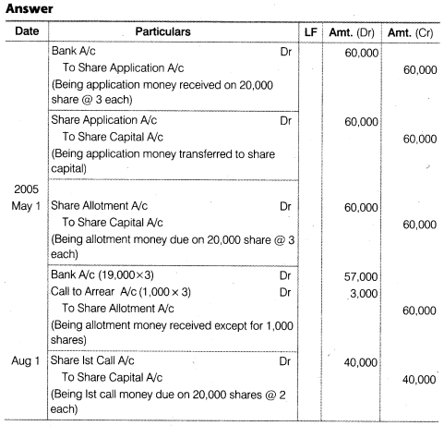

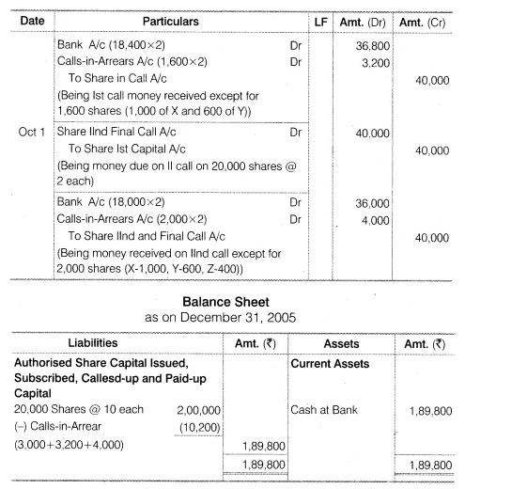

NCERT Solutions for Class 12 Accountancy Part II Chapter 1 Accounting for Share Capital
September 29, 2019 by Sastry CBSE

NCERT Solutions for Class 12 Accountancy Part II Chapter 1 Accounting for Share Capital
NCERT SolutionsCBSE Sample Papers AccountancyClass 12 Accountancy

Test Your Understanding I
• State which of the following statements are true
(a) A company is formed according to the provisions of Indian Companies Act, 1932.
Answer False
(b) A company is an artificial person.
Answer True
(c)Shareholders of a company are liable for the acts of the company.
Answer False
(d) Every member of a company is entitled to take part in its management.
Answer False
(e) Company’s shares are generally transferable.
Answer True
(f) Share application account is a personal account.
Answer True
(g) The director of a company must be a shareholder.
Answer True
(h) Application money should not be less than 25% of the face value of shares.
Answer False
(i) Paid-up capital can exceed called-up capital. .
Answer True
(j) Capital reserves are created from capital profits.
Answer True
(k) Securities premium account is shown on the assets side of the balance sheet.
Answer False
(l) Premium on issue of shares is a capital loss.
Answer False
(m) At the time of issue of shares, the maximum rate of securities premium is 10%.
Answer False
(n) The part of capital which is called-up only on winding up is called reserve capital.
Answer True
(o) Forfeited shares can not be issued at a discount.
Answer False
(p) The shares originally issued at discount may be re-issued at a premium.
Answer True

Do it Yourself I
Question 1. On January 01, 2006, a limited company was incorporated with an authorised capital of Rs.40,000 divided into shares of Rs.10 each. It offered to the public for subscription of 3,000 shares payable as follows
Rs.
On Application 3 per share
On Allotment 2 per share
On First Call (One month after allotment) 2.50 per share
On Second and Final Call 2.50 per share
The shares were fully subscribed for by the public and application money duly received on January 15, 2006. The directors made the allotment on February 1, 2006.
How will you record the share capital transactions in the books of a company if the amounts due has been duly received, and the company maintains the combined account for application and allotment.
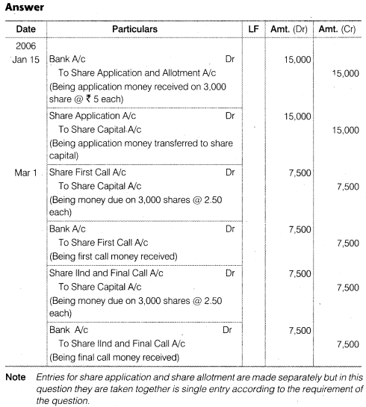

Do it Yourself II
- A company issued 20,000 equity shares of Rs.10 each payable at Rs.3 on
application, Rs.3 on allotment, Rs.2 on first call and Rs.2 on second and the
final call. The allotment money was payable on or before May 01, 2005; first
call money on or before August Ist, 2005; and the second and final call on or
before October Ist, 2005;

‘X’, whom 1,000 shares were allotted, did not pay the
allotment and call money; ‘Y’, an allottee of Rs.600 shares, did not pay the
two calls; and ‘Z’, whom 400 shares were allotted, did not pay the final call.
Pass journal entries and prepare the Balance Sheet of the company as on
December 31, 2005.
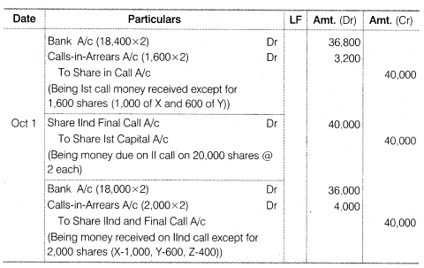
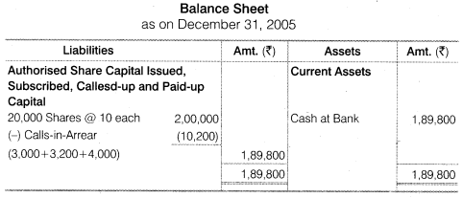

Notes to accounts

Authorised capital --------------------

Issued capital 20000*10 2,00,000

Suscribed capital 200000

Less calls in arrears 10200
[3000+3200+4000] -------------
189800

- EQUITY AND CAPITAL
- Share holders funds
Share capital 189800

- Alfa company Ltd. issued 10,000 shares of Rs.10 each for cash payable at Rs.3
on application, Rs.2 on allotment and the balance in two equal instalments.
The allotment money was payable on or before March 3, 2006; the first call
money on or before 30 June, 2006; and the final call money on or before 31st
August, 2006. Mr. ‘A’, whom 600 shares were allotted, paid the entire remaining
face value of shares allotted to him on allotment. Record journal entries in
company’s books and also prepare their balance sheet on the date.
- 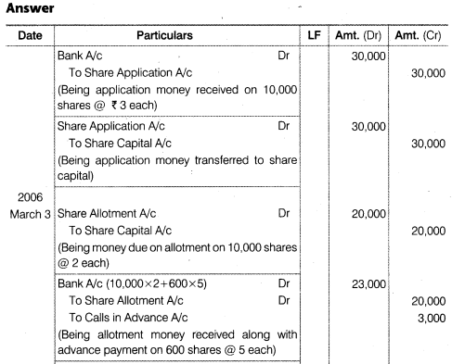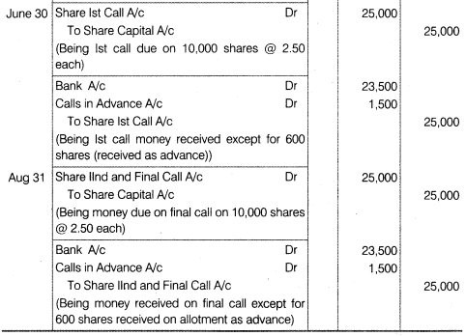

. What are the uses of securities premium?
Answer When securities like shares and debentures are issued to public more than their face value the excess is called security premium. As per the Section 78 of the Companies Act 1956, the amount of securities premium can be used by the company for the following purposes
(i) For paying up unissued shares of the company to be issued to members (shareholders) of the company as fully paid bonus share.
(ii) For writing off the preliminary expenses of the company.
(iii) For writing off the expenses of, or the commission paid or discount allowed on, any issue of shares or debentures of the company.
(iv) For paying up the premium that is to be payable on redemption of preference shares or debentures of the company.
(v) Further, as per the Section 77A, the securities premium amount can also be utilised by the company to buy-back its own shares.

What is buy-back of shares?
Answer When a company repurchase its own share from the market to reduce the number of share it is called buy-back of shares. As per the Section 77A of the Companies Act, 1956 the procedure for buy back of share would be as follows
(i) First of all the Articles of the Association must authorise the company for the buy-back of shares.
(ii) A special resolution must be passed in the companies’ Annual general body meeting.
(iii) The amount of buy-back of shares should not exceed 25% of the paid-up capital and free reserves.
(iv) The debt-equity ratio should not be more than a ratio of 2:1 after the buyback.
(v) All the shares of buy-back should be fully paid-up.
(vi) The buy-back of the shares should be completed within 12 months from the date of passing the special the resolution.
(vii) The company should file a solvency declaration with the Registrar and’ SEBI which must be signed by at least two directors of the company. –

Mohit Glass Ltd. issued 20,000 shares of Rs.100 each at Rs.110 per share, payable Rs.30 on application, Rs.40 on allotment (including Premium), Rs.20 on first call and Rs.20 on final call. The applications were received for 24,000
shares and allotted 20,000 shares and reject 4,000 shares and amount returned thereon. The money was duly received. Give journal entries.
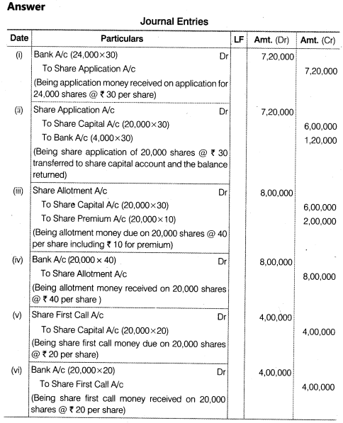

6. A limited company offered for subscription of 1,00,000 equity shares of Rs.10 each at a premium of Rs.2 per share. 2,00,000. 10% Preference shares of Rs.10 each at par.
The amount on share was payable as under :
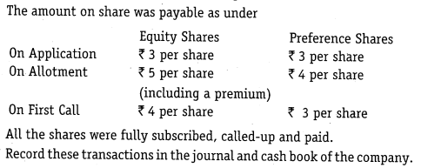
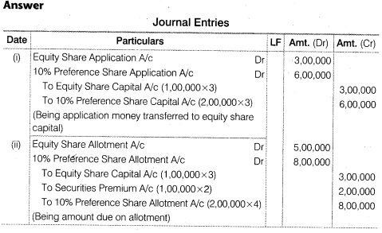
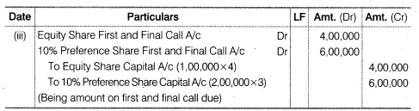
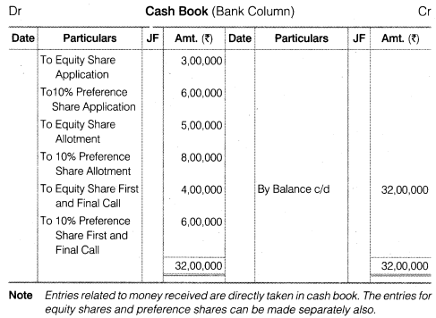
7. Eastern Company Limited, having an authorised capital of Rs.10,00,000 in shares of Rs.10 each, issued 50,000 shares at a premium of Rs.3 per share payable as follows :
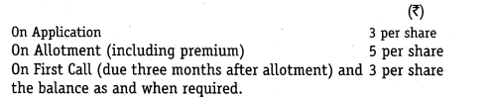
Applications were received for 60,000 shares and the directors allotted the shares as follows :
(a) Applicants for 40,000 shares received shares, in full.
(b) Applicants for 15,000 shares received an allotment of 8,000 shares.
(c) Applicants for 5000shares received 2000 shares on allotment, excess money being returned.
All amounts due on allotment were received. The first call was duly made and the money was received with the exception of the call due on 100 shares.
Give journal and cash book entries to record these transactions of the company. Also prepare the Balance Sheet of the company.
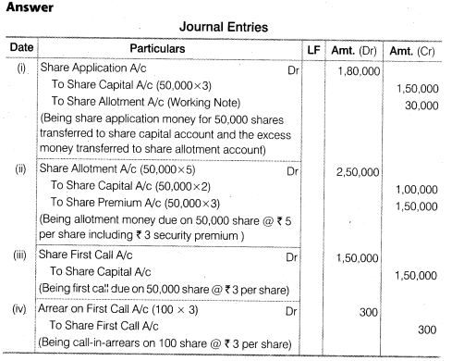
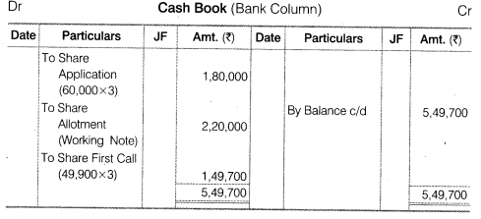

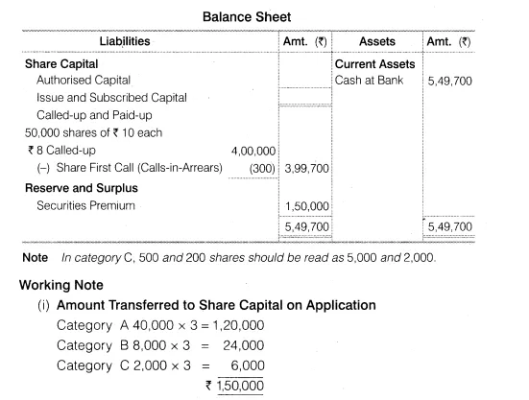
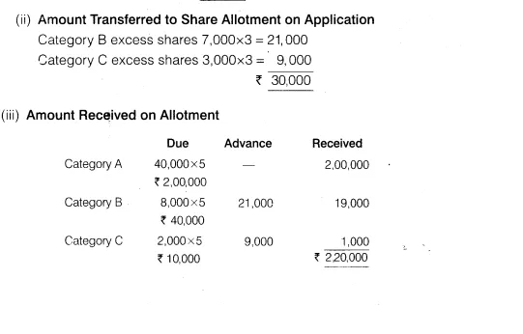

FORFEITURE AND REISSUE OF SHARES
If a shareholder fails to pay the allotment money and/or any subsequent calls, then the company has the right to forfeit shares by giving a proper notice to the shareholder.

As per the Table A of the Company Act, the procedure of forfeiting shares is mentioned below.
1. A notice is sent to default shareholder stating him/her to pay Calls in Arrears along with the interest accrued on the outstanding calls money within a period of 14 days of the receipt of notice, otherwise, the shares will be forfeited.
2. If the shareholder does not pay the amount, then the company has the right to forfeit his/her share by passing a resolution.
3. A notice of that resolution is send to the default shareholder and a public notice of the same is published in a daily newspaper.
4. The name of the shareholder is removed from the register of members (i.e. shareholders).

Accounting Treatment for Forfeiture of Shares:

i) Forfeiture of Shares that were issued at Par

Share Capital A/c |  | Dr. | (amount called up)
 | To Share Allotment A/c |  | (amount not received)
 | To Share Calls A/c |  | (amount not received)
 | To Share Forfeiture A/c |  | (amount received)
(Shares forfeited)

ii) Forfeiture of Shares that were issued at Premium
a) If premium is received, then the premium is not shown.

Share Capital A/c |  | Dr. | (amount called up)
 | To Share Allotment A/c |  | (amount not received)
 | To Share Calls A/c |  | (amount not received)
 | To Share forfeiture A/c |  | (amount received)
(Share forfeited)

b) If premium is not received, then the premium is shown.

Share Capital A/c |  | Dr. | (amount called up excluding premium)
Share Premium A/c |  | Dr. | (amount not received)
 | To Share Allotment A/c |  | (amount not received including premium)
 | To Share Calls A/c |  | (amount not received)
 | To Share Forfeiture A/c |  | (amount received including premium)
(Share forfeited)

Naman Ltd issued 20,000 shares of Rs 100 each, payable Rs 25 on application, Rs 30 on allotment , Rs 25 on first call and The balance on final call. All money duly received except Anubha, who holding 200 shares did not pay allotment and calls money and Kumkum, who holding 100 shares did not pay both the calls. The directors forfeited shares of Anubha and kumkum.
300 shares reissue at Rs.70+[30]
Give journal entries.

ANSWER:
Books of Naman Ltd

Date | Particulars |  |  | L.F. | Debit  Amount  Rs | Credit  Amount  Rs
 | Bank A/c |  | Dr. |  | 5,00,000
 |  | To Share Application A/c |  |  |  | 5,00,000
 | (Shares Application money received for 20,000 shares @ Rs 25 each)
 | Share Application A/c |  | Dr. |  | 5,00,000
 |  | To Share Capital |  |  |  | 5,00,000
(Share Application money of 20,000 shares @ Rs 25 each
transferred to Share Capital Account)
 | Share Allotment A/c |  | Dr. |  | 6,00,000
 |  | To Share Capital A/c |  |  |  | 6,00,000
 | (Share Allotment due on 20,000 shares @ Rs 30 each)
 | Bank A/c  Call in arrears A/c Dr. |  | Dr. |  | 5,94,000  6000
 |  | To Share Allotment A/c |  |  |  | 6,00,000
 | (Allotment money received for 19,800 shares @ Rs 30 per share and unpaid from Anubha 200share @ Rs. 30 per share)
 | Share First Call A/c |  | Dr. |  | 5,00,000
 |  | To Share Capital A/c |  |  |  | 5,00,000
 | (Share First Call money due on 20,000 @ Rs 25 per share)
 | Bank A/c  Calls in arrears A/ c Dr.[200+100] |  | Dr. |  | 4,92,500  7500
 |  | To Share First Call A/c |  |  |  | 5,00,000
 | (Share First Call received @ Rs 25 per share for 19,700 shares)
 | Share Final Call A/c |  | Dr. |  | 4,00,000
 |  | To Share Capital A/c |  |  |  | 4,00,000
 | (Share Final Call money due on 20,000 shares @ 20 per share)
 | Bank A/c  Calls in arrears A/c Dr.[200+100] |  | Dr. |  | 3,94,000  6000
 |  | To Share final call A/c |  |  |  | 4,00,000
(Share Final Call received @ Rs 20 per Share for 19,700
shares and 300 shares failed to pay the call)
 | Share Capital A/c |  | Dr. |  | 30,000
 |  | To Share Forfeiture A/c (200×25+100×55) |  |  |  | 10,500
 |  | To Share Allotment [calls in arrears] (200×30) |  |  |  | 6,000
 |  | To Share First Call A/c (300×25) |  |  |  | 7,500
 |  | To Share Final Call A/c (300×20) |  |  |  | 6,000
 | (300 Shares forfeited)  Bank A/c Dr.  Capital reserveA/c Dr.  To share capital |  |  |  | 21000  9000
 |  |  |  |  |  | 30000

Alternatively this question can be solved by debiting Calls in Arrears Account

Books of Naman Ltd

Date | Particulars |  |  |  | L.F. | Debit  Amount  Rs | Credit  Amount  Rs
 | Bank A/c |  |  | Dr. |  | 5,00,000
 |  | To Share Application A/c |  |  |  |  | 5,00,000
 | (Share Application money received on application for 20,000 shares @ Rs 25 per share)
 | Share Application A/c |  |  | Dr. |  | 5,00,000
 |  | To Share Capital A/c |  |  |  |  | 5,00,000
(Share Application money for 20,000 shares @ Rs 25 per share
transferred to Share Capital Account)
 | Share Allotment A/c |  |  | Dr. |  | 6,00,000
 |  | To Share Capital A/c |  |  |  |  | 6,00,000
 | (Share Allotment money due on 20,000 shares @ Rs 30 per share)
 | Bank A/c |  |  | Dr. |  | 5,94,000
 | Calls in Arrears A/c |  |  | Dr. |  | 6,000
 |  | To Share Allotment A/c |  |  |  |  | 6,00,000
(Allotment money received for 19,800 shares @ Rs 30 per
share and 200 shares failed to pay the Allotment)
 | Share First Call A/c |  |  | Dr. |  | 5,00,000
 |  | To Share Capital A/c |  |  |  |  | 5,00,000
 | (Share First Call money due on 20,000 shares @ Rs 25 per share)
 | Bank A/c |  |  | Dr. |  | 4,92,500
 | Calls in Arrears A/c |  |  | Dr. |  | 7,500
 |  | To Share First Call A/c |  |  |  |  | 5,00,000
(Share First Call money for 19,700 shares @ Rs 25
each received except 300 shares)
 | Share Final Call A/c |  |  | Dr. |  | 4,00,000
 |  | To Share Capital A/c |  |  |  |  | 4,00,000
 | (Share Final Call money due on 20,000 shares @ Rs 20 per share)
 | Bank A/c |  |  | Dr. |  | 3,94,000
 | Calls in Arreras A/c |  |  | Dr. |  | 6,000
 |  | To Share final call A/c |  |  |  |  | 4,00,000
(Share Final Call money received for 19,700 shares @ Rs 20 per share
except 300 shares)
 | Share Capital A/c |  |  | Dr. |  | 30,000  9000
 |  | To Share Forfeiture A/c (200×25+100×55) |  |  |  |  | 10,500
 |  | To Calls in Arrears A/c |  |  |  |  | 19,500
 | (300 Shares forfeited on account failed to pay the money due)

Working Note:

1. Forfeited Amount

Amount on application | (300 shares @ Rs 25 each) | = | 7,500
Amount on allotment | (100 Shares @ Rs 30 each) | = | 3,000
 |  |  | 10,500

Himalaya Company Limited issued for public subscription of 1,20,000 equity shares of Rs 10 each at a premium of Rs 2 per share payable as under :
With Application | Rs 3 per share
On allotment (including premium) | Rs 5 per share
On First call | Rs 2 per share
On Second and Final call | Rs 2 per share
Applications were received for 1,60,000 shares. Allotment was made on pro-rata basis. Excess money on application was adjusted against the amount due on allotment.
Rohan, whom 4,800 shares were allotted, failed to pay for the two calls. These shares were subsequently forfeited after the second call was made. All the shares forfeited were reissued to Teena as fully paid at Rs 7 per share.
Record journal entries in the books of the company to record these transactions relating to share capital. Also show the company’s balance sheet.

ANSWER:
Books of Himalaya Company Ltd.
Journal
Date | Particulars |  | L.F. | Debit  Amount  Rs | Credit  Amount  Rs
 | Bank A/c | Dr. |  | 4,80,000
 | To Share Application A/c |  |  |  | 4,80,000
 | (Share Application money received for 1,60,000 shares @ Rs 3 per share)
 | Share Application A/c | Dr. |  | 4,80,000
 | To Equity Share Capital A/c |  |  |  | 3,60,000
 | To Share Allotment A/c |  |  |  | 1,20,000
 | (Share Application for 1,20,000 shares @ Rs 3 per share transferred to Share Capital Account and remaining amount adjusted to Allotment)
 | Share Allotment A/c | Dr. |  | 6,00,000
 | To Equity Share Capital A/c |  |  |  | 3,60,000
 | To Securities Premium |  |  |  | 2,40,000
 | (Share Allotment due on 1,20,000 shares @ Rs 5 per share including Rs 2 Securities Premium)
 | Bank A/c | Dr. |  | 4,80,000
 | To Share Allotment A/c |  |  |  | 4,80,000
 | (Share allotment for 1,20,000 shares @ Rs 5 per share received)
 | Share First Call A/c | Dr. |  | 2,40,000
 | To Equity Share Capital A/c |  |  |  | 2,40,000
 | (Share First Call due on 1,20,000 shares @ Rs 2 per share)
 | Bank A/c | Dr. |  | 2,30,400
 | To Share First Call A/c |  |  |  | 2,30,400
 | (Share First Call received on 1,15,200 shares @ Rs 2 per share and 4,800 shares failed to pay)
 | Share Final Call A/c | Dr. |  | 2,40,000
 | To Equity Share Capital A/c |  |  |  | 2,40,000
 | (Share Final call due on 1,20,000 shares @ Rs 2 per share)
 | Bank A/c | Dr. |  | 2,30,400
 | To Share Final Call A/c |  |  |  | 2,30,400
 | (Share Final Call received on 1,15,200 shares @ Rs 2 per share and 4,800 shares failed to pay)
 | Equity Share Capital A/c (4,800⋅10) | Dr. |  | 48,000
 | To Share First Call A/c (4,800⋅2) |  |  |  | 9,600
 | To Share Final Call A/c (4,800⋅2) |  |  |  | 9,600
 | To Share Forfeiture A/c (4,800⋅6) |  |  |  | 28,800
 | (4,800 shares forfeited for the non-payment of First Call and Final Call)
 | Bank A/c | Dr. |  | 33,600
 | Share Forfeiture A/c | Dr. |  | 14,400
 | To Equity Share Capital |  |  |  | 48,000
 | (4,800 shares reissued @ Rs 7 per share, fully paid-up)
 | Share Forfeiture A/c | Dr. |  | 14,400
 | To Capital Reserve A/c |  |  |  | 14,400
 | (Share forfeiture balance of 4,800 shares transferred to Capital Reserve Account)

Himalaya Company Limited
Balance Sheet
Particulars | Note No. | Amount  (Rs)
I. Equity and Liabilities
1. Shareholders’ Funds
a. Share Capital | 1 | 12,00,000
b. Reserves and Surplus | 2 | 2,54,400
2. Non-Current Liabilities
3. Current Liabilities
Total |  | 14,54,400
II. Assets
1. Non-Current Assets
2. Current Assets
a. Cash and Cash Equivalents | 3 | 14,54,400
Total |  | 14,54,400
NOTES TO ACCOUNTS
Note No. | Particulars |  | Amount  (Rs)
1 | Share Capital
 | Authorised Share Capital
 | …….. shares of Rs 10 each |  | -
 | Issued Share Capital
 | 1,20,000 shares of Rs 10 each |  | 12,00,000
 | Subscribed, Called-up and Paid-up Share Capital
 | 1,20,000 shares of Rs 10 each |  | 12,00,000
2 | Reserves and Surplus
 | Securities Premium | 2,40,000
 | Capital Reserve | 14,400 | 2,54,400
3 | Cash and Cash Equivalents
 | Cash at Bank |  | 14,54,400

Issue of shares consideration other than cash
Rs. 500000/100=5000shares[nominal /par]
Rs. 540000/120= 4500shares[premium]
Rs 540000/90=6000 shares[discount]
Number of share to be issued=Amount payable/issue price

2,000 Equity Shares of ₹ 10 each were issued to Limited from whom assets of ₹ 25,000 were acquired .
Pass Journal entry.

ANSWER:
Journal
Date | Particulars |  | L.F. | Debit  Amount  Rs | Credit  Amount  Rs
 | Assets A/c | Dr. |  | 25,000
 | To X Ltd. |  |  |  | 25,000
 | (Assets bought from X Ltd.)
 | X Ltd. | Dr. |  | 25,000
 | To Share Capital A/c |  |  |  | 20,000
 | To Securities Premium A/c |  |  |  | 5,000
 | (2,000 shares of Rs 10 each issued to X Ltd.)

'Amrit Dhara Ltd.' issued 800 Equity Shares of ₹ 100 each at a premium of 25% as fully paid-up in consideration of the purchase of plant and machinery of ₹ 1,00,000.
Pass entries in company's Journal.

ANSWER:
Books of Amrit Dhara Limited
Journal
Date | Particulars |  | L.F. | Debit  Amount  (₹) | Credit  Amount  (₹)
 | Plant & Machinery A/c | Dr. |  | 1,00,000
 | To Vendor A/c |  |  |  | 1,00,000
 | (Machinery purchased)
 | Vendor A/c | Dr. |  | 1,00,000
 | To Equity Share Capital A/c (800 ×× 100) |  |  |  | 80,000
 | To Securities Premium A/c (800 ×× 25) |  |  |  | 20,000
 | (Shares issued to vendor at a premium of ₹ 25 per share)

Rajan Ltd . purchased assets from Geeta & Co . for ₹ 5,00,000. A sum of ₹ 1,00,000 was paid by means of a bank draft and for the balance due Rajan Ltd. issued equity Shares of ₹ 10 each at a premium of 25%. journalise the above transactions in the books of the company.

ANSWER:
Books of Rajan Limited
Journal
Date | Particulars |  | L.F. | Debit  Amount  Rs | Credit  Amount  Rs
 | Assets A/c | Dr. |  | 5,00,000
 | To Geeta & Co. |  |  |  | 5,00,000
 | (Assets purchased from Geeta & Co.)
 | Geeta & Co. | Dr. |  | 1,00,000
 | To Bank A/c |  |  |  | 1,00,000
 | (Payment made to Geeta & Co.)
 | Geeta & Co. | Dr. |  | 4,00,000
 | To Equity Share Capital A/c |  |  |  | 3,20,000
 | To Securities Premium A/c |  |  |  | 80,000
 | (32,000 equity shares of Rs 10 issued at 25% premium)
Working Note-
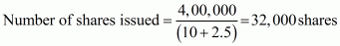

Z Ltd . purchased furniture costing ₹ 2,20,000 from C.D Ltd. The payment was to be made by issue of 9% Preference Shares of ₹ 100 each at a premium of ₹ 10 per share . Pass necessary Journal entries in the books of Z Ltd.
Books of Z Ltd.
Journal
Date | Particulars |  | L.F. | Debit Amount  Rs | Credit Amount  Rs
 | Assets A/c | Dr. |  | 2,20,000
 | To C.D Ltd. |  |  |  | 2,20,000
 | (Assets purchased from C.D Ltd.)
 | C.D Ltd. | Dr. |  | 2,20,000
 | To 9% Preference Share Capital |  |  |  | 2,00,000
 | To Securities Premium A/c |  |  |  | 20,000
 | (2,000 9% Preference Shares of Rs 100 each issued at 10% premium to C.D Ltd.)
Working Note:
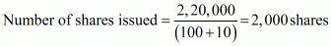
Goodluck Ltd purchased machinery costing ₹ 10,00,000 from Fair Deals Ltd. The company paid the price by issue of Equity Shares of ₹ 10 each at a premium of 25%.
Pass necessary Journal entries for the above transactions in the books of Goodluck Ltd.

ANSWER:
Books Goodluck Ltd.
Journal
Date | Particulars |  |  | L.F. | Debit  Amount  Rs | Credit  Amount  Rs
 | Machinery A/c |  | Dr. |  | 10,00,000
 | To Fail Deals Ltd. |  |  |  |  | 10,00,000
 | (Machinery purchased from Fair Deals Ltd.)
 | Fair Deals Ltd. | Dr. |  |  | 10,00,000
 | To Equity Share Capital A/c |  |  |  |  | 8,00,000
 | To Securities Premium A/c |  |  |  |  | 2,00,000
 | (80,000 equity shares of Rs 10 each issued at 25% premium)
Working Note:

Jain Ltd purchased machinery costing ₹ 10,00,000 from Ayer Ltd. 50% of the payment was made by cheque and for the remaining 50% , the company issued Equity Shares of ₹ 100 each at a premium of 25% . Pass necessary Journal entries in the books of Jain Ltd . for the above transaction.

ANSWER:
Books of Jain Ltd.
Journal
Date | Particulars |  | L.F. | Debit  Amount  Rs | Credit  Amount  Rs
 | Machinery A/c | Dr. |  | 10,00,000
 | To Ayer Ltd. |  |  |  | 10,00,000
 | (Machinery purchased from Ayer Ltd.)
 | Ayer Ltd. | Dr. |  | 5,00,000
 | To Bank A/c |  |  |  | 5,00,000
 | (Payment made to Ayer Ltd.)
 | Ayer Ltd. | Dr. |  | 5,00,000
 | To Equity Share Capital A/c |  |  |  | 4,00,000
 | To Securities Premium A/c |  |  |  | 1,00,000
 | (4,000 equity shares of Rs 100 each issued at 25% premium)
Working Note-
